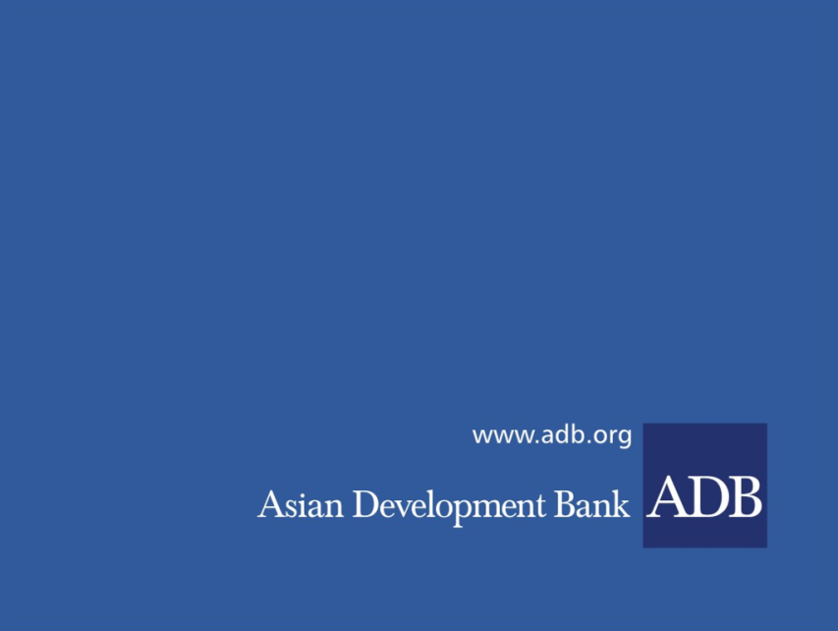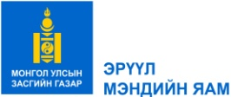

**VACANCY ANNOUNCEMENT FOR PROJECT**

**IMPLEMENTATION UNIT STAFF**

(re-advertise)

**Date:** 31 January 2023

**Project number:** Loans 3843/3844 and Grant 0672-MON

**Project name:** Improving Access to Health Services for Disadvantaged Groups Investment Program

**Position:** Project implementation unit staff

1. **BACKGROUND**

The Ministry of Health is continuing the recruitment process for the vacant positions of the PIU staff for "Improving Access to Health Services for Disadvantaged Groups Investment Program" by the Asian Development bank.

We are re-advertising **3** positions for which no applicants have submitted materials.

1. **SCOPE**

Vacancy notices of Project Implementation Unit Staff’s Positions:

1. Contract specialist
2. Health financing expert
3. Administration, training and public relations specialist
4. **REQUIREMENTS**

Please refer to the following link for each Terms of reference for PIU staff:

[**https://moh.gov.mn/p/152**](https://moh.gov.mn/p/152)

1. **APPLICATION SUBMISSION PROCEDURE**

Interested applicants should submit an application consisting of the following documents, prepared in English and Mongolian languages:

* Cover letter (maximum 1 page) explaining the reasons for applying for the positions, describing how the candidate’s qualification, skills and work experiences meet the selection criteria;
* Curriculum Vitae with ID photos (3x4) attached;
* 2 reference letters from a previous employer/supervisor or persons who know the candidate well;
* Copies of all diplomas and certificates;
* Other supporting documents (such as information on previously conducted similar works, proof of English language proficiency etc).

All documents should be submitted through the e-mail below or in person to the following contact address before 4:00 PM on **13 February 2023.**

**Contact information:**

The Ministry of Health of Mongolia,

Sukhbaatar district, Olympic Street 2,

Government Building-8, Room No.311

Ulaanbaatar, Mongolia

Tel: +976-51-263820

E-mail: [sansarmaa@moh.gov.mn](mailto:sansarmaa@moh.gov.mn)